Meeting Brief: Stakeholder Engagement on Utilization of Residual Clinical Samples for Multi-pathogen Serosurveillance
27 March 2026 | Royal Tulip Hotel, Nairobi

Background and purpose
Serological surveillance (serosurveillance) entails the measurement of antibody levels. It can be used to evaluate the performance of disease prevention and control programs, including immunization, and to estimate disease burden thereby informing public health efforts. Since 2021, researchers at the KEMRI-Wellcome Trust Research Programme (KWTRP) have conducted multi-pathogen serosurveillance in collaboration with other institutional organizations and stakeholders. The Kenya Multi-site Serosurveillance (KEMIS) collaboration conducted multi-pathogen serosurveillance utilizing samples collected from residents of five health and demographic surveillance system (HDSS) sites in Kenya. However, prospective population-based serosurveillance is costly and HDSS sites may not be fully geographically representative. During the KEMIS dissemination meeting, participants proposed various ways to improve the sustainability and geographical coverage of multi-pathogen serosurveillance, including the utilization of residual clinical samples.
The utilization of residual clinical samples for multi-pathogen serosurveillance will be piloted as part of the KWTRP study, “Integrated Serosurveillance and Modelling in Kenya” (the I-SAM Study). On 27th March 2026, KWTRP researchers hosted a stakeholder engagement meeting on the utilization of clinical residual samples for serosurveillance, bringing representatives from Jaramogi Oginga Odinga Teaching and Referral Hospital, Mama Lucy Kibaki Hospital, Kilifi, Kakamega, Machakos, Kiambu and Nakuru Counties Teaching and Referral Hospitals as well as representatives from the Ministry of Health’s Division of Disease Surveillance and Response (DDSR) and the National Vaccine and Immunization Program (NVIP).

Overall aim
The overall aim of the stakeholder engagement meeting was to inform participants about the proposed program on utilizing residual clinical samples for multi-pathogen serosurveillance, seek their support, and identify effective implementation strategies. We also used the opportunity to feedback findings on multi-pathogen serosurveillance from the KEMIS project.
The objectives of the stakeholder engagement meeting were to:
- Introduce the I-SAM Study to key national and county stakeholders.
- Discuss the study’s relevance to the existing national surveillance priorities and systems.
- Explore opportunities for collaboration and stakeholder participation.
- Agree on coordination mechanisms and next steps.

Meeting snapshot
Overview of the proposed work
The objectives of this multi-pathogen serosurveillance workstream will be to: assess the level of population immunity and evaluate the performance of routine vaccination programs for vaccine preventable diseases; monitor exposure to outbreak prone pathogens (arboviruses); and to understand the dynamics of malaria transmission, population burden and monitor the performance of the malaria immunization program. The proposed sample collection sites are shown in Figure 1. Residual samples will be collected according to a predefined sampling scheme to ensure demographic representation across age and sex categories. The proposed approach is to utilize residual blood samples drawn from patients seen in outpatient service areas, including antenatal clinic (ANC).
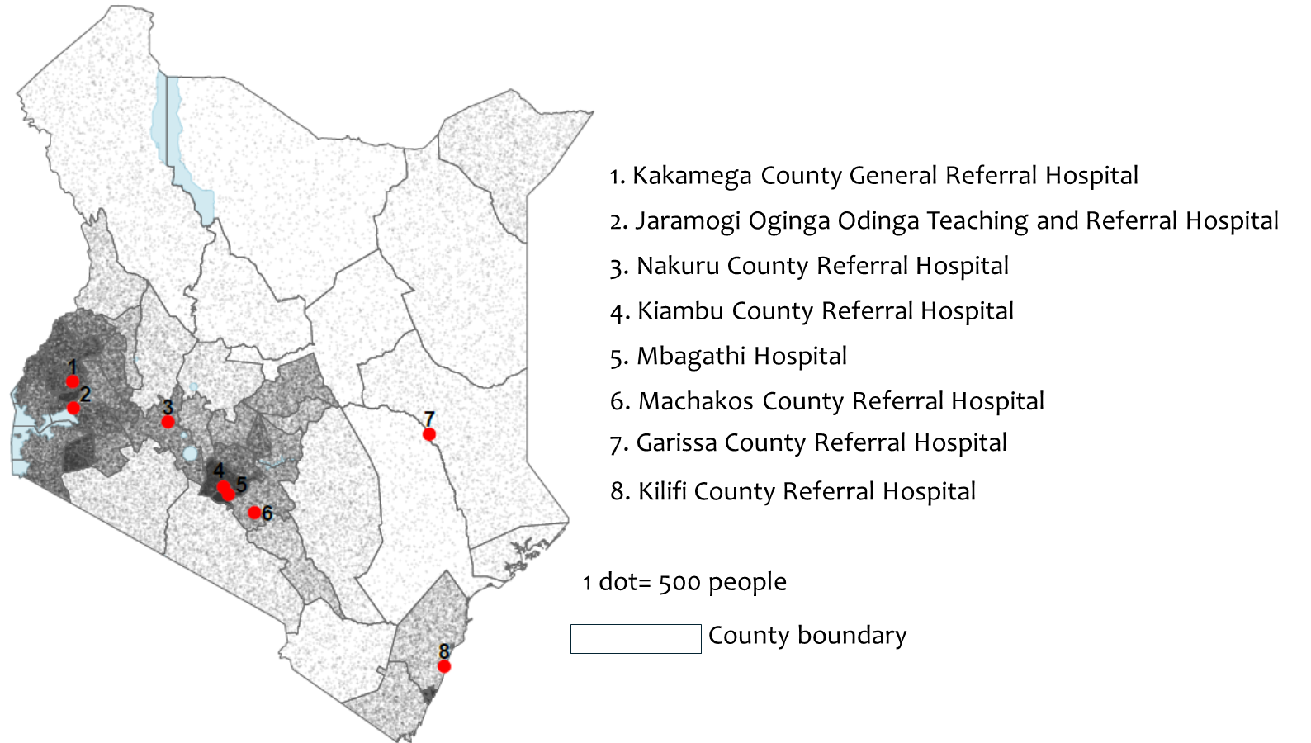
Figure 1: List of selected health facilities for residual sample collection

Effective implementation strategies
We held breakout sessions where group members discussed:
- Potential challenges with residual clinical sample collection and mitigation strategies.
- Laboratories to target for residual sample collection.
- Potential challenges with the quality of metadata with laboratory registers and approaches to improve it.

The participants agreed that it would be possible to reach the target sample sizes across the age categories with a caveat that outpatient service area samples may need to be supplement with inpatient service area samples for children aged <5 years. Sample integrity was also raised as a potential limitation across all age groups; this could be mitigated by standardizing phlebotomy procedures, monitoring lab rejection criteria and implementing corrective actions as needed and considering the utilization of residual inpatient samples where stratum-specific sampling criteria are not met. Meeting participants also highlighted the need to standardise laboratory registers as well as retraining staff (clinicians, laboratory technicians, and data clerks) on the need and rationale for capturing routine laboratory registry data. Lastly, meeting participants agreed on the need to collect samples from outpatient and ANC clinics and recommended that we consider samples from blood transfusion centres. However, there may be biased sampling when using residual blood donor samples, and it is age restricted to approximately 15-64 years.

Key recommendations
The key recommendations from the stakeholders participating in the meeting were as follows:
- The need to involve and engage all relevant stakeholders in managing the project and to communicate key findings in real real-time to all stakeholders including the Ministry of Health’s DDSR and NVIP.
- The need to be flexible in sampling, particularly for children aged <5 years where we should consider sampling from hospitalized patients to supplement the outpatient samples.
- The role of serosurveillance in planning supplementary immunization activities and the need to include it within the National Disease Surveillance Guidelines currently under revision.
- The stakeholders also highlighted the need to include hospitals run by faith-based organizations in future residual sampling as they may serve a considerable proportion of the general population.
- Harmonize the metadata requirements (age, sex, diagnosis, location, service area) and their capture across all facilities with integration of this information into digital systems where possible.
- The need to validate seroprevalence estimates against those estimated from serosurveillance among more general population-representative samples.
Key Messages from the meeting:
- The use of residual clinical samples for disease surveillance is feasible and is cost-effective way for expanding the multi-pathogen serosurveillance work in Kenya while ensuring sample integrity and demographic representation with future expansion to faith-based hospitals.
- Strong stakeholder coordination and data synchronization are crucial. This incorporates standardizing laboratory registers to ensure limited metadata is missing during patient registration, retraining the data clerks on the need to capture key information at registration and sharing the serosurveillance outcomes with key partners.
- The use of residual clinical samples for disease surveillance can generate actionable public health evidence that can support monitoring of immunization programs and detect potential disease spillover, thus strengthening outbreak preparedness and has potential of being integrated into the revised national Disease Surveillance Guidelines.
Figure 2: Participants for the central engagement meeting held on the 27^{th of} March 2026 at Royal Tulip hotel, Nairobi
Conclusion
This central stakeholder engagement meeting surfaced key insights for piloting multi-pathogen serosurveillance utilizing residual clinical samples, including effective strategies for achieving the target stratum-specific sample sizes and collecting associated metadata. Participants felt that this approach to serosurveillance can generate actionable public health evidence and has the potential to be included in the national disease surveillance protocol currently under revision.
Acknowledgments
We thank all the stakeholders who attended the central engagement meeting and actively participated in discussions throughout the meeting. The meeting was supported by the Gates Foundation, however, the views expressed and the details herein are not those of the Gates Foundation.
Meeting participants
Rose Ombati¹, Juliet Odhiambo¹, Collins Owino¹, Cecilia Mtanje², Ben Kitole², Hassan Ahmed Bachu², David Juma Onoka³, Ignatius Yongo Omondi³, Jeremiah Nyoni³; Hillary Kiverenge⁴, Emily Atieno⁴, Jacqueline Amira⁴, Hassan Hussein Nurie⁵, Amina Daudi⁵, Evans Odhiambo⁵, Kipchirchir Tanui⁶, Christine Nawire Were⁶, Symon Tanui⁶, Joseph Nzomo⁷, David Mutunga Matuku⁷, David Ngaruma⁷, Martin Maitima⁸, Mary Maina⁸, Francis Nganga⁹, Oscar Gaunya⁹, Wesley Mugambi¹⁰

¹KEMRI Wellcome Trust Research Programme; ²Kilifi County Referral Hospital; ³Jaramogi Oginga Odinga Teaching and Referral Hospital; ⁴Kakamgea County General Referral Hospital; ⁵Garissa County Referral Hospital; ⁶Nakuru County Referral Hospital; ⁷Machakos County Referral Hospital; ⁸Mama Lucy Kibaki Hospital; ⁹Department of Disease Surveillance and Response MoH Kenya; ¹⁰National Vaccines and Immunization Program, MoH Kenya.

